DWAS organizes:
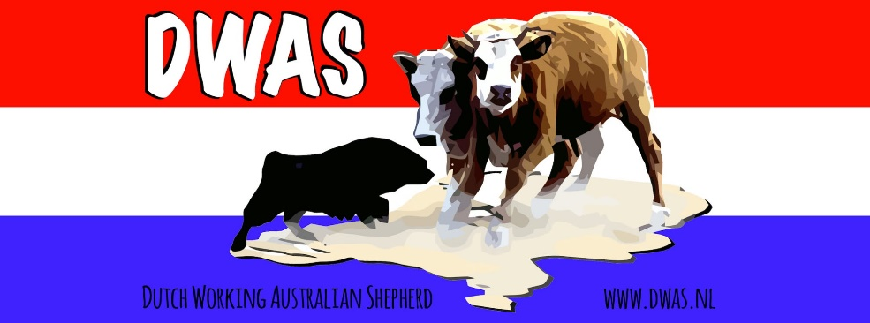
The first Dutch open championship time and points trial
May 23 and 24 2026
Judged by Erika Ham ( The Netherlands)
Location : JJRanch, schoterlandseweg 42, 8412TA, Hoornsterzwaag
This trial is open for all herding breeds
Saturday May 23 will be the qualification rounds. All dogs have to work sheep and ducks.
The 10 highest combined sheep/ducks scores in each class will move on to the final rounds on Sunday.
Sunday 24th there will be 2 rounds sheep/ ducks. The highest combined score out of the 4 runs is the winner and therefore Open Dutch Champion
Time start : Handlersmeeting around noon ( 12 oclock)
Courses : to be explained during the meeting
Classes:
- Open: Any dog of any age may compete in the Open class. Any handler may compete in the Open class. A dog who has competed in any Advanced class (includes ALL other Associations and/or Non-Sanctioned Trials) is no longer eligible to compete in the Open class.
- Advanced: The Advanced class is limited to dogs who are not competing in the Open class Any dog may compete in the Advanced class.

HANDLER RULES:
- It is each handler’s responsibility to familiarize themselves with the rules and the trial host/ coursedirector has the responsibility to enforce these rules at each trial. Any questions on rules should be discussed before the trial begins.
- A handler shall not enter the trial field at any time with any kind of training device. This includes, but is not limited to, remote controlled devices, dummy or weighted collars, any device used to distract or cause pain to a dog. The trial official has the right to inspect a dog for any suspected violations of this rule and may disqualify a handler if he/she enters the trial field with any such equipment.
- A handler is responsible for injury to livestock and property, both on and off of the trial field that results from a dog being loose and/or out of control.
- All dogs should be kept securely tied, on a leash, or in a crate when not competing. While realizing that ropes can be chewed and chains can be broken, if a dog gains access to the trial course while competition is under way through negligence of the owner/handler, a trial official has the right to access disciplinary action against the dog and its owner, including disqualification of the handler and dog for the duration of the trial being held.
- Handlers should always demonstrate sportsmanlike conduct.
- While recognizing that it is often necessary for a dog to bite the livestock to make a turn, excessive or out of control biting will NOT be tolerated. A dog that hangs onto, or runs alongside the livestock as the livestock runs down the arena, will NOT be tolerated. If the trial official deems the conduct to be excessive, the handler/dog will be disqualified for that run.

How does this work?
There will be a number of obstacles that need to be taken in order. Every head trough a obstacle is a point.
Every run starts with an outrun , handlers positions according to level/ class.
One head through obstacle and the others nowhere near or one head over runaway line means you`re done with this obstacle.
No retries ! Exception when stock is lingering around an obstacle without going through or crossing runaway line . Handlers might try to accomplish this obstacle until one through or one crossing runaway line .
Judge calls out loudly how much head are through and tell you to move on .
Head in pen count only if gate is closed in time .
Open: handlers line in the upper third of arena/field
Advanced: handlers have to stay in a circle approx 5 meter diameter in the upper arena , start from there . Handlers are allowed to leave their restricted area after obstacle 3 is accomplished.
Judge : calls time on griping , over working or clearly chasing and dog out of handlers control.
Points earned till then will count.
Time stops when pen gate closes.

Entryfee :
50 euro per dog working sheep/ducks.
If you are qualified and want to run the finals, you pay a one time fee of 50 euro, to be paid before the finals start. For this you get to have 2 go rounds on sheep and ducks.
Entry form below.
Entries start March 30 at noon.
Sent entries to stockdog@dwas.nl
Transfer the entry fee to :
DWAS account NL30RABO0301245819
BIC : RABONL2U

Coursedirector : Anneke de Jong
jjranch@hetnet.nl

Entry Form Dutch Open Time Points Trial
@ JJRanch, The Netherlands

Breeed _________________________________________________

Registered Name ______________________________________________

Registry ____________________________________________

Birthdate____________________________________________

Call Name ______________________________
E-Mail ____________________________________
Phone number ______________________________
Class Entry : Open/ Advanced

Please circle appropriate classes. (Use a separate entry for each dog. Make sure proper fees are enclosed. Non -payment will result in non-entry!)
IMPORTANT — READ THIS FIRST:
Release: I agree to assume all responsibility for any claim, loss, or damage, or whatever kind or nature, whether to person or property, which may be caused at or near this event, either directly or indirectly, by me or the dog or dogs I have entered in or brought to this event. I further agree that I will hold the the DWAS and its officers, directors, agents and members; and the property and stock owners and their agents, harmless and defend them from any and all liability for any injury, claim, damage or loss, of whatever kind or nature, whether to person property, caused at or near this event, whether directly or indirectly, by me or any dog I have entered in or brought to this event. I agree to indemnify the DWAS; and the property and stock owners, for any loss, cost or expense including attorneys fees and costs, to which the DWAS, or the property and stock owners, might be subject as a result of any claim, suit, loss or damage caused in any way by any act or negligence on my part or on the part of any dog or dogs I have entered in or brought to this event.. I certify and represent that the dog or dogs I have entered in or brought to this event is/are not a hazard to other dogs, other animals, or to people.

Signature of entrant Date

